Entrance to all events and services is free – as are refreshments.

However for those events involving hot food we require prior notification of your intention to be present.
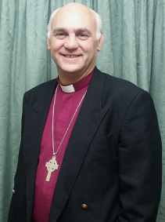
These events are the
Thursday Worship & Lunch,
‘Bright & Beautiful’ (The Ladies Evening)
and Men’s Breakfast

Transport, if required, is available
to all events and services.

Speaker at all events
and services will be
Bishop Ken Clarke

Contacts

Mission Secretary For general enquiries
and bookings for events involving catering

Telephone (028) 9258 3078
Mobile 07786 627 618
Email lambegmissionsecretary@gmail.com

Transport To request transport

Telephone (028) 9266 2678

Rector Other Enquiries

Telephone (028) 9266 3872
Mobile 07747 194 753 Email rectorlambegparish@live.co.uk

Parish Website http://lambeg.connor.anglican.org/
LAMBEG PARISH
Church of Ireland

YOUR INVITATION
TO

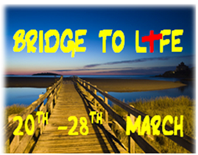

‘I am come that they may have life,
and have it to the full.’ John 10.10

Programme details inside

Wednesday 20th March

7.30 p.m. Girls’ Brigade Evening in the Church Hall
for Girls, Officers and Parents.

Thursday 21st

12.00 noon Informal Worship, followed by lunch,
in the Hilden Centre for housebound and those
who normally find it difficult to attend Church.
Transport available

7.45 p.m. Worship in Church

Friday 22nd

7.30 p.m. ‘Bright & Beautiful’ in the Hilden Centre Ladies Event (Including Fork Supper)

Saturday 23rd

8.30 a.m. Men’s Breakfast in the Hilden Centre
Palm Sunday 24th In Church
9.30 a.m. Holy Communion with short address

10.45 a.m. Family Service

6.30 p.m. Evening Worship
Followed by a time of prayer for healing
and the ‘Laying on of hands’

Monday 25th

7.45 p.m. Bowlers’ Evening in the Church Hall
Bishop’s ‘Select’ v Lambeg Bowling Club
Everyone welcome to come along and view
‘The Showdown’!
Tuesday 26th

7.45 p.m. Worship in Church

Wednesday 27th

7.45 p.m. Worship in Church

Thursday (Maundy Thursday) 28th

10.30 a.m. Holy Communion

7.45 p.m. Closing Worship of Mission

Worship in the parish continues with

Good Friday 29th

10.00 a.m. March of Witness with local churches starting
at St Columba’s Church , Derryvolgie, continuing to Harmony Hill Presbyterian Church and
St Colman's Roman Catholic Church
before finishing at Lambeg Parish Church
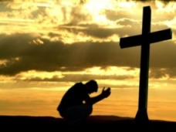
7.45 p.m. Good Friday Service in Church
‘A celebration of the Cross’

EASTER SUNDAY 31st March 2013 in Church

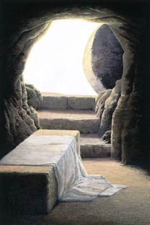
‘Christ is risen!’

9.30 a.m. Holy Communion

10.45 a.m. Family Communion
for the whole parish

6.30 p.m. Evening Worship

