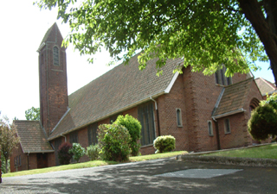

MUSICAL EVENING
FRIDAY 4TH APRIL, 2014
7.30pm

Music by

City of Belfast School of Music

Flute Ensemble – Wind Quintet
Harp Ensemble – Cantanti
Various Soloists
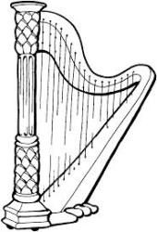Tickets £10 (to include light supper)
Available by telephoning (028) 9077 7647
or from a member of the Fundraising Group

