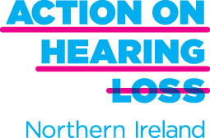



**2 Hour Appeal!**

* Can you spare 2 hours a month?
* Do you have a hearing loss or are you interested in helping people who do?
* Would you like to support your local community?

Action on Hearing Loss is working in partnership with the Northern HSCT to provide FREE hearing aid clinics in your area. This Hear to Help service is volunteer led and we need YOUR help. 2 hours per month could provide your community with a free hearing aid clinic.

You will be fully trained to re-tube hearing aids, provide basic maintenance and advice to those in need.

Interested? Please contact:

**Wendy McColm,**

Beeches Community Services Centre,

76 Avondale Drive,

Ballyclare, BT39 9EB.

Mobile: 07940 160672

**Email :** [**wendy.mccolm@hearingloss.org.uk**](mailto:wendy.mccolm@hearingloss.org.uk)

Action on Hearing Loss is a registered charity in England and Wales (207720) and Scotland (SC038926).