A COURSE TO EXCITE, ENTHUSE, AND ENCOURAGE ~ as well as educate!

This is a brilliant course – accessible to all, rewarding to study, and practical for use where you are… many people around the country have already done it. Why wait?

What will be covered?

Sessions will include:
- What is pastoral care? What about the mission context?
- Pastoral care and the mission of the Church. Small groups and pastoral care.
- Pastoral care in the context of mission, sickness, healing and salvation.
- Qualities and skills. Listening and referring, avoiding dependency, caring for the team and the limits of pastoral care.
- Loss, death and bereavement.

How is it taught?

Five evening sessions with a mixture of teaching, group discussion and activities. It is very relaxed and good fun!

Who will teach it?

Your tutor will be Sister Valerie Thom, Community Evangelist for Upper Shankill.

When and where is the course being taught?

The course time and dates are 7.30pm – 9.30pm on:
30 Sep, 7 Oct, 14 Oct, 21 Oct, 28 Oct

Venue

Holy Trinity Parish Halls, Ballysillan, Belfast

How to Register

Please email Peter Hamill (peter.traincoord@connor.anglican.org) or detach the registration form overleaf and send to:-

Peter Hamill, Diocesan Training Co-ordinator, Church of Ireland House, 61-67 Donegall Street, Belfast BT1 2QH. Phone 91857827

Registration Form –
Pastoral Care in a Mission Context 2009

Name

Parish

Phone

Comments on the Course (from participants on Belfast course)

‘This has been a wonderful opportunity to share experiences from other people’
‘I have really loved the opportunity to meet people from other parishes and find out what they do there.’
‘The course has been run in a lovely informal way and the teaching has been gentle yet fascinating.’
‘I can’t wait to use these skills in my parish.’
‘I came on the course having not been to any type of training for many years and it has been wonderful how I have learnt new skills and made new friends’

The number of places will be limited,
so make sure you register for yours now

Pastoral Care in a Mission context – An introduction to Pastoral Visiting

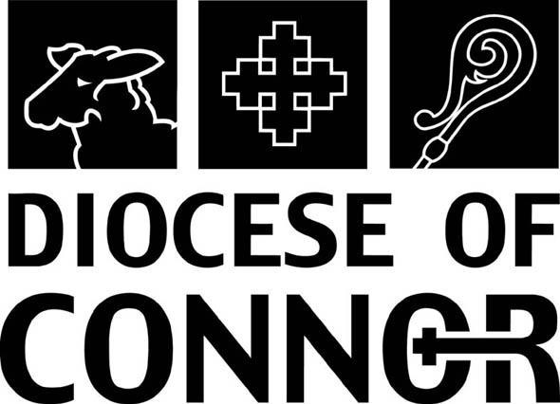

Wednesdays 7.30 pm – 9.30 pm
Commencing 30th September 2009 Holy Trinity Parish Halls, Ballysillan, Belfast

