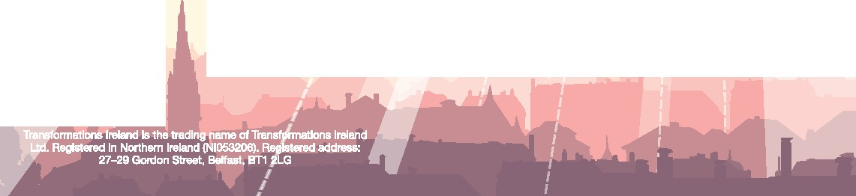I
Registration )\
By Post:
Transformations Ireland
248 Clandeboye Road
Bangor
BT191QB

By email:info@transfonnations-ireland.org Online:www.transformations-ireland.org For further information call:07841096571

Registration Form - £20(to include lunch)

Name

Address

Postcode Email Phone
Ienclose

Number andnames of people attending

As lunch is included please indicate
any special dietary needs

Please make chequespayable toTransformations Ireland
and send tothe above postal address.

Transformatio
If

Kairos Trust

One Day Conference

prCUJer
THROUGH

With
Roy and Daphne Godwin from
Ffald-y-Brenin Wales

22.11.14

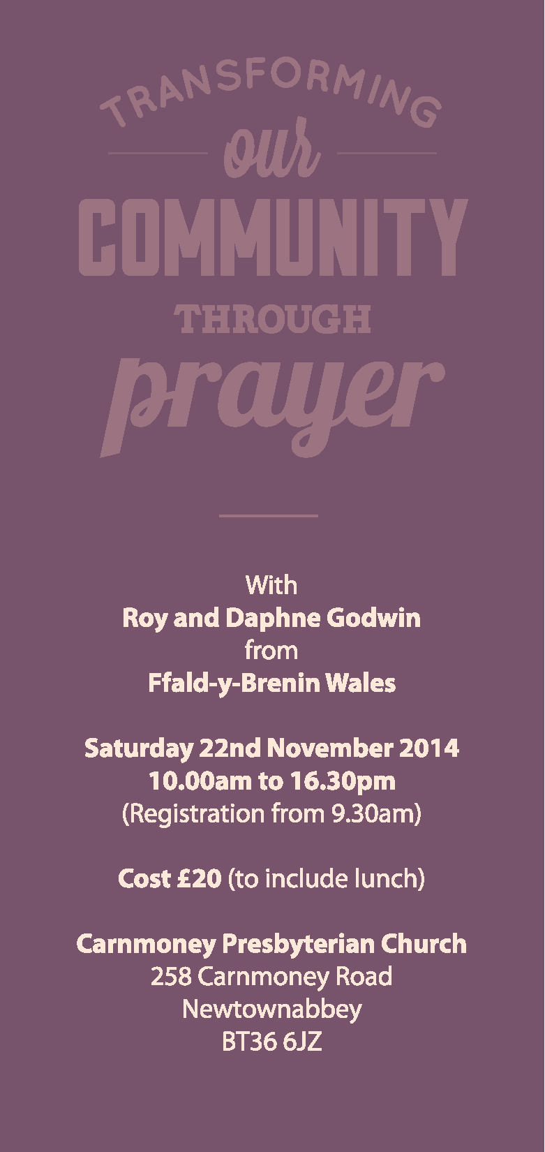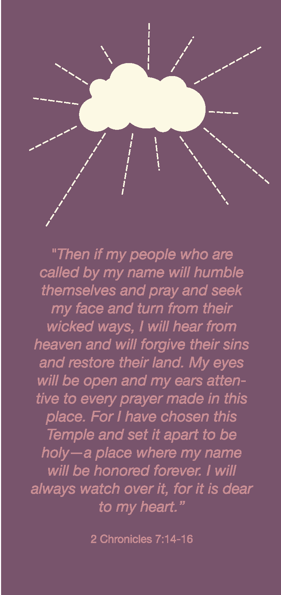

We all hunger to see people healed, con­
verted, blessed, and communities changed.
'Grace outpouring" is the book you may have read which told the amazing story of what God has been doing at Ffald-y-Brenin in South West Wales. It is also the name of the conference you may have attended last year.

But the Vision of Roy and Daphne Godwin the directors of Ffald-y-Brenin is much larger than the wonderful things God is doing there. They want to see prayers of blessing redupli­ cated in many communities across the world. They call it setting up 'Houses of Prayer', but what they mean is ordinary Christians getting together to pray for the people and the schools, churches, hospitals, community centres around them. They are keen to share this message and to show how simple it is even for those who have never been to a prayer meeting or a 'house of prayer'.

Come to this day conference in Carnmoney and find out how to 'change our community through prayer'. Places are limited so early enrolment is advised.

Programme for the day

10.00-12.30 Worship & Session 1 & 2
13.15-15.00 Worship & Session 3
15.15 -16.30 Session 4

Speakers:Roy & Daphne Godwin
Worship: Andy Rogers & Dave Dickinson

