A SPIRITUAL JOURNEY
---TO THE---
HOLY LAND

24 May – 2 June 2016
with the Revd. Canon David Humphries and the Revd. Amanda Adams

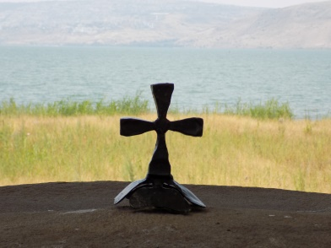

Travel with us to the Holy Land and let the Bible come alive as we meet the people and see the places of the gospel stories. The Holy Land is unique in offering so many highlights and contrasts in such a compact area.

On our journey we will visit the principal pilgrimage sites in Jerusalem as we follow in the footsteps of Jesus from his birth in Bethlehem; his time of preparation in the dramatic and forbidding wilderness of Judea to his lakeside ministry around the sea of Galilee, experiencing for ourselves what it was like to live beside and sail upon this magnificent lake and even sample its fish!

We will travel the road from Jerusalem to Jericho as the Good Samaritan did; visit the Mount of Olives and the Garden of Gethsemane; walk along the Via Dolorosa as we retrace Christ’s path to the cross before visiting the empty tomb and experiencing the joy of the resurrection not only in Jerusalem but also in Emmaus.

This pilgrimage will also allow us to follow in the footsteps of John the Baptist visiting such places as his birthplace in the beautiful village of Ein Karem and the site on the Jordan River where John baptised Jesus. We will explore the mystery of John’s resting place when we travel to ancient Samaria, and his connection with ancient Qumran where the Dead Sea Scrolls were discovered.

We will also be able to experience life in Jesus’ time in the village of Nazareth and compare this to life as it is for some of the children of the Holy Land today when we visit a Christian run home and school in Bethany.

And still there is more! To find out how much more why not attend one of the information evenings being organised by David and Amanda on:
Saturday 26 September at St Molua’s Stormont, 2pm
Tuesday 29 September at Ballyrashane Glebe Hall, 8pm
For a brochure and further details contact:
Canon David Humphries, St Molua’s Rectory, 3 Rosepark, Belfast BT5 7RG
(Tel. 028 9048 2292)

