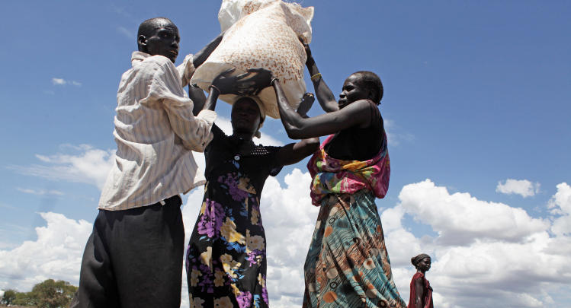
South Sudan Crisis Appeal

Famine has emerged in parts of South Sudan’s Unity State where currently 100,000 people are at risk of starvation, and a further one million people are classified as on the brink of famine.
4.9 million people are in urgent need of food.
Those affected have already experienced three years of conflict, and are at breaking point with harvests being disrupted, increasing food and fuel prices, and the collapse of the economy – people are struggling to feed their families and have been surviving on wild foods, and drinking unsafe water.
Response costings
£15 / €17 provides fishing gear
£30 / €35 provides seeds and tools
£50 / €58 provides a family with a shelter and other essential items.
£150 / €175 covers the cost of cash vouchers to enable people to buy food in their local community.
£500 / €580 will repair a hand pump which will provide clean water.
Without immediate action this crisis will continue to claim lives.

Rosie Crowther, Christian Aid’s South Sudan Country Manager explains ‘I have witnessed first-hand the incredible resilience of South Sudanese people in the face of many crises. However, many people have now exhausted their coping mechanisms, and tens of thousands could die of starvation, millions do not know where their next meal is coming from. Tragically, this crisis was utterly preventable… The situation will continue to deteriorate rapidly if we don’t act now’.
What is Christian Aid doing?
Our partners are working to provide humanitarian assistance in some of the worst-affected and most remote parts of South Sudan, and we will be supporting them both in their short-term relief efforts and in the long-term as they work to bring lasting and sustainable peace to communities.
In Unity State, we have been supporting our partner UNIDO who are distributing fishing gear to give people an immediate means of sourcing nutritious food. UNIDO are also repairing boreholes to provide access to safe water, as well as providing shelter materials, fast-maturing vegetable seeds and farming tools to families so they have immediate and long term access to food.
The Sudan Peace and Education Development Programme has been drilling new boreholes and rehabilitating existing ones, they are also teaching people how to keep themselves safe from diarrhoea and diseases. They are also distributing cash so children can now access two meals a day.
Our partner CADA is working to provide families with vegetable seeds, fishing gear and agricultural training.
To prevent the spread of disease we are also distributing hygiene kits, which include soap, sanitary products, jerry cans and mosquito nets.
Our partners are also providing plastic sheeting so that people can build temporary shelters to protect themselves from the harsh heat of the sun.
Through our partners:
- 2,000 households have received hygiene kits and materials to build shelters.
- 3,000 displaced people in camps have received food relief, including maize flour, beans, cooking oil and salt.
- 14,000 have improved access to clean water through the rehabilitation of 15 water pumps.
- 22,500 displaced people have received mosquito nets, medical kits, water purification tablets and hygiene kits.

How can you help?
Donate – Give directly to our appeal online christianaid.ie/southsudan or by telephoning your local office

Pray – Pray for those who do not have enough to eat, for the provision of clean water and for health and hygiene. Ask God’s blessing upon Christian Aid’s partners and for the church in South Sudan, that she will be empowered to broker peace and bring reconciliation.
Organise a collection – You can make a real difference to people affected by holding a collection for South Sudan. You can order your envelopes from your local office.
South Sudan
South Sudan is the world’s newest nation, but in December 2014, fighting erupted in Juba (the capital), and quickly spread to the Greater Upper Nile region. Countries in the region were quick to convene peace talks, resulting in the signing of a Cessation and Hostilities Agreement in January 2014. Despite months of talks, political agreements have been consistently violated, and later in 2014 a famine was only narrowly averted due to humanitarian assistance.
Christian Aid has been working in Unity State providing humanitarian relief for some time (with the support of Irish Aid), but we urgently need to upscale our response as reports are confirming that cholera and measles are rife, and there are almost 2 million cases of malaria. There is a shortage of basic drugs and medical supplies.
Christian Aid is also supporting the work of the South Sudan Council of Churches, which has continued to encourage an end to the conflict, preaching messages of peace and accountability and calling for parties to sign a peace agreement.
Belfast: Christian Aid Ireland, Linden House, Beechill Business Park, 96 Beechill Road, Belfast, BT8 7QN | Tel: 028 9064 8133
Dublin: Christian Aid Ireland, Canal House, Canal Road, Dublin |Tel: 00353 1 496 7040
Cork: Hill View, Bandon, Cork | Tel: 00353 23 884 1468

Christian Aid Ireland is a registered charity in the Republic of Ireland, Charity Registration no. 20014162 (CHY6998) and in Northern Ireland, Charity Registration no, NIC101631 (XR94639)

