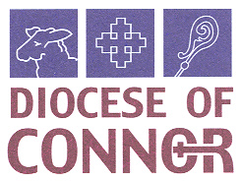
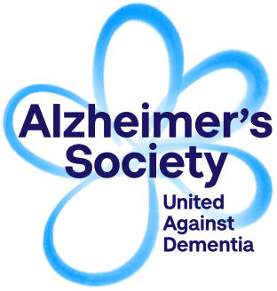
An information morning, facilitated by Alzheimer's Society, the UK's leading dementia charity is being held in All Saints' Parish Centre, Antrim on Tuesday 21 November at 9.30am.

The aim of the morning is to make us more aware of a condition that affects the lives of many of our parishioners and will help raise our awareness of issues that many people live with on a daily basis. The morning workshop will include What is dementia?
Communication Skills with a person affected by dementia, environmental factors, behaviours and what support is available.

At present there are nearly 20,000 people living in Northern Ireland who are living with a diagnosis of dementia. The Alzheimer's Society are the leading charity in the UK who provide information, support and signposting. They provide information and support, improve care, fund research, and create lasting change for people affected by dementia. They are united against dementia until a cure is found we will strive to create a world where those affected by dementia are supported and accepted, and be able to live in their community without fear of prejudice.

Timetable

9.30am Arrival and coffee
10.00am Session 1
11.00am comfort break
11.15am Session 2
12.15pm Questions and Answers
12.30pm snack lunch
1.00pm depart
————————————————————————————
I WILL/WILL NOT be attending the Information morning on Tuesday 21st November 2017
I WILL /WILL NOT REQUIRE A SNACK LUNCH
DIETARY REQUIREMENTS ________________________
PARISH_________________________________________________
SIGNED________________________________________________
Please return to: Mrs Rosemary Patterson
Email: rosemarypatterson@connordiocese.org

Please complete the reply slip and return before Tuesday 14th November 2017

