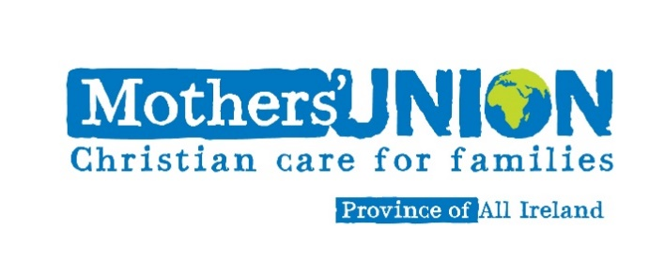

**Clergy Newsletter**

**Spring 2018**

**AFIA: Away From It All Holidays**

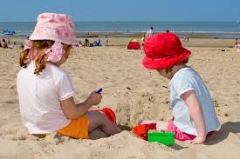Whilst some statistics have yet to arrive, already we know that six dioceses sent 45 children and 38 adults on holiday in 2017. This has brought great joy to these families in their hour of need.

[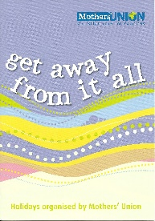](http://www.google.ie/url?sa=i&rct=j&q=&esrc=s&source=images&cd=&cad=rja&uact=8&ved=0ahUKEwjwj4Hnu_LMAhVCOMAKHXtyDvkQjRwIBw&url=http://muenterprises.org/birmingham/resources/leaflets/&psig=AFQjCNE3csARbzre-U_c5BLRBAoiXrzvdg&ust=1464170869819003)Clergy are in an ideal position to make Referrals. The procedure entails your completing a Referral Form and the applicant also has to complete and sign an application form. There will be a contact number and address of the AFIA Coordinator to return it to, and once the family fit the criteria and the funds allow the coordinator will work closely with the family in a confidential manner to arrange a break that best suits their requirements.

AFIA holidays are available throughout Ireland and if your particular diocese is not in a position to be able to help they will put you in touch with another.

[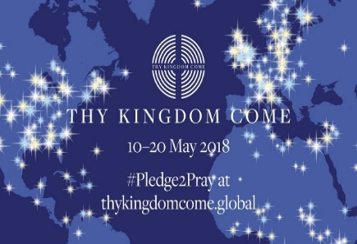](https://www.google.co.uk/url?sa=i&rct=j&q=&esrc=s&source=images&cd=&cad=rja&uact=8&ved=2ahUKEwjz9_GmntXZAhXC8ywKHTanDzkQjRx6BAgAEAY&url=https://twitter.com/thykingdom_come&psig=AOvVaw3EZK08VOqlFz-mJRuKZtup&ust=1520341096533756)**Thy Kingdom Come**

*"Prayer is at the heart of who we are. It takes us deep into our relationship with our loving God...We are living in troubled, anxious and uncertain times and in such times, our prayers are, quite possibly, more important than ever"*

 - Bishop Andrew Proud, Mothers' Union Central Chaplain

Following the success of *Thy Kingdom Come events of 2017* worldwide. Mothers’ Union has been invited by Lambeth Palace to host another Global Moment in 2018 and encourage members around the world to participate! This will take place on Monday, 14th May.

<http://www.mothersunion.org/ThyKingdomCome>

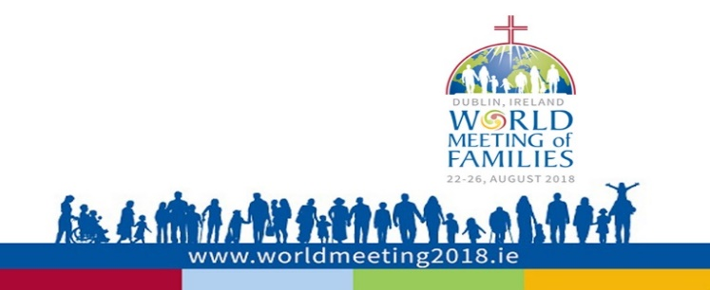

***Souls of Our Shoes***

Mothers’ Union has been offered a dedicated prayer space in Christ Church Cathedral during the World Meeting of Families 2018 which runs from 22nd -26th August.

This space will be host to a *Souls of Our Shoes* Exhibition. This idea originated with the Scottish Interfaith Group on Domestic Abuse of which Mother’s Union is a member. Members who were at the General Meeting in Edinburgh last September found the exhibition powerful and compelling.

Its primary purpose is to raise awareness of domestic abuse and to provide a safe space where individuals and families may come to talk, contemplate and pray. *Souls of Our Shoes* consists of a set of physical shoes with comments from those that have walked away from abuse and comments from people of faith.

It has been found to be an effective starting point for people and communities to start talking about domestic abuse and lets the many in abusive situations know that there are people of faith concerned for them.

***‘Souls of Our Shoes’* is planning to visit Church of Ireland General Synod in the City Hotel, Armagh from the 10th – 12th May. Please visit the MU stand and join with us in our call to end domestic abuse.**

<http://www.worldmeeting2018.ie/en/>

www.mothersunion.ie

**________________________________________________________**

[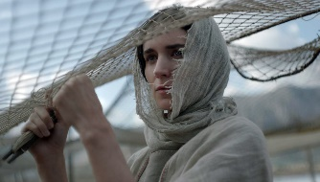](http://www.google.co.uk/url?sa=i&rct=j&q=&esrc=s&source=images&cd=&cad=rja&uact=8&ved=0ahUKEwi7xpq489zZAhWM3KQKHVQtD2YQjRwIBg&url=http://variety.com/2018/film/reviews/mary-magdalene-review-1202710195/&psig=AOvVaw3cZrmIztTPhLiuU632p7hX&ust=1520604506551028)

**Mary Magdalene**

Once again Mothers’ Union has partnered with Damaris Media to offer a free resource for the film *Mary Magdalene*. A Companion Booklet which explores the issues addressed within the film, Mary Magdalene, from a biblical perspective is now available to download at

<http://www.mothersunion.org/sites/default/files/files/Mary%20Magdalene%20Film%20Companion%20Booklet.pdf>

**________________________________________________________**

***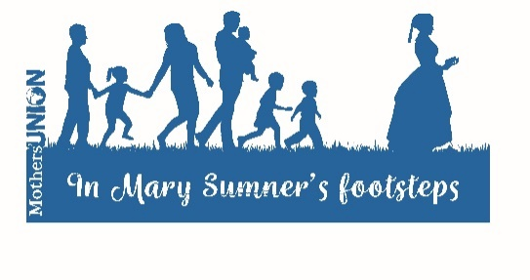*Mums in May 2018**

Mums in May, Mothers' Union Triennial Fundraising project enables us to reach out into our communities and share the vision, the excitement and the support which Mothers’ Union brings to those who are most vulnerable in our society, both locally and globally.

This year we are encouraged to take up the theme of *In Mary Sumner’s Footsteps* and get walking! We also have a Fireside Quiz, a tea cosy competition and /or a tea cosy story competition. All are welcome to pariticpate if there is a *Mums In May* event near you. Diocesan Presidents will have the details of what is planned in your diocese.

**MU Worldwide Update: Parenting**

Mothers’ Union have programmes as far apart as Myanmar, Jamaica and Guyana.



**Parents in Jamaica** continue to face many challenges in maintaining stability in family life. Problems range from lack of finances, unemployment to poor behavioural management which in turn is creating a lot of stress on families.

Some parents are looking for answers as to how to deal with these and other difficulties. One parent who was trained at a Mothers’ Union-run parenting workshop in Old Harbour said,

*‘I was thinking of calling the Child Development Agency (CDA) or the National Parenting Support Commission to find out if they had any parenting workshops in Old Harbour that I could attend and my principal told me about the workshop at the church, I said: “Thank you Jesus”. What I was looking for came right to me.’*

**This is Mothers’ Union in action, providing a vital contribution towards the home and family empowering parents on how to raise children and take care of themselves.

Our parenting programme in Jamaica continues to be active throughout the island, working in schools, churches and the wider community.

**“Dear Lord…..” a new prayer resource from MU**

[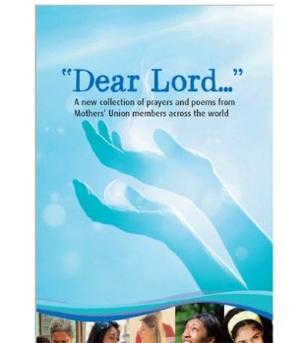](https://mueshop.org/product/dear-lord-prayer-book-pre-order-due-feb-b0056/)Since its launch in February over 3,000 copies of Mothers’ Union’s new prayer book have been sold. **‘Dear Lord’** is a collection of over 150 prayers and reflections, contributed by Mothers’ Union members all over the world, offering words for every occasion to encourage and inspire, whether in public services or personal prayer time

*‘I am delighted to commend this wonderful new resource to you as an inspirational prayer tool.’*

Lynne Tembey, Worldwide President, Mothers’ Union

Price is just £3.00 / €3.50

**To order please contact your local branch or order directly from** [**www.mueshop.org**](http://www.mueshop.org)

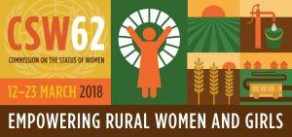

**CSW62: Empowering Rural Women and Girls**

In March seven Mothers’ Union representatives, attended the UN’s Commission on the Status of Women in New York to lobby at a very practical level on behalf of economic empowerment for rural women and girls.

The lack of economic empowerment; inequalities in accessing education and skills training; decent paid work; as well as discrimination within the workplace and the global gender gap in income and employment, which currently stands at 59% mean that *women worldwide bear the brunt of poverty*.

<http://www.themothersunion.org/mu-uncsw>

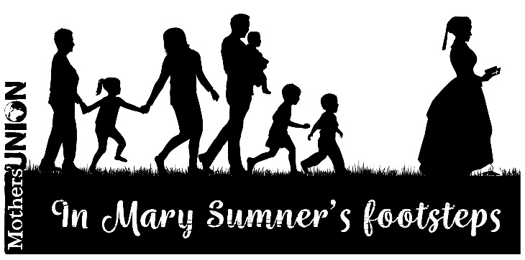

Thank you for your continued support for Mothers Union. Further details of Mothers Union activities can be found at [www.mothersunion.ie](http://www.mothersunion.ie) or at [www.mothersunion.org](http://www.mothersunion.org)