

North Belfast

Centre of Mission

May 2018

Karen Webb

Stephen Whitten

*“Behold I am doing a new thing; can you not see it? I am making a way in the wilderness and streams in the wasteland”*

*Isaiah 43:19*

Rejoice – I am doing a new thing!

A group of people posing for the camera

Description generated with very high confidenceThis was the beautiful sign in Down Cathedral the day that Stephen Whitten married Loren Thompson. It was such a privilege to witness Stephen and Loren committing to each other for life – a new thing under God!

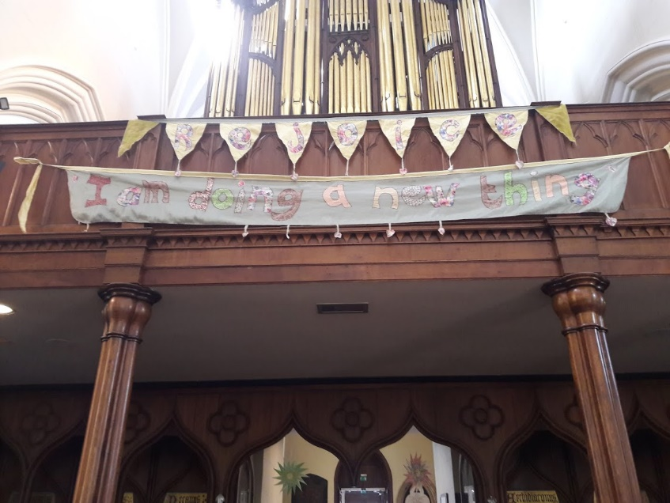We have been so aware of the “new things” God is doing through and with our Centre of Mission here in North Belfast. This is an opportunity to let you all know what is happening and how you can support us in practical & prayerful ways.

Updates

TLG – Transforming Lives for Good

We are coming to the end of our first year of TLG mentoring with our 6 coaches and we look forward to welcoming some more coaches for a new school in a new academic year. The more children we can mentor and help to engage with education better, the better chance they have to reach their full potential. We thank God for the doors opening and we pray for more coaches to help make this a reality.

Xplore Weekend Outreach

In March we had the Xplore weekend here to our Centre of mission – it was a weekend of very bad snow – but nothing would stop the Xplore young people and they came anyway – and had an amazing time chatting and praying with people in the area – at one stage they even delivered some basic food stuff to people snowed in. It is such an encouragement to us when these young people come and support the Base.

A person sitting at a table with a cake

Description generated with very high confidence

Baby Basics – We are delighted to welcome a new face onto the Baby Basics Team – Heather Gibson (Lisburn Cathedral) who has agreed to be our volunteer and help with the practical side of Baby Basics and packing the baskets for collection by the Health Professionals. We are currently getting a lot of referrals and averaging 6 a week.

Holy Week

During the week before Easter, we had an outreach to the area, supported local clergy & staff and students from the Queens University Chaplaincy. We ran a kid’s club for 2 afternoons, had an Easter Egg Hunt around the shops and prayed for people on the street. We had a great finish to the week, with a Walk of Witness from Glencairn estate to Whiterock estate. Giving away small wooden crosses and Easter eggs.

CAP – Christians Against Poverty

We started a Life Skills class for 8 weeks in partnership with Rev Tracey McRoberts, St Matthew’s – we had 8 people who engaged with it and who all changed their money habits. We all learnt something and enjoyed our community time together around the lunch table.

After- Schools Drop in

We now have 24 children coming along to our After-schools Drop in. Great fun and we now read to them at the end of each session from the Chronicles of Narnia!

Prayers

Thank you…

* For continued relationships with the local churches.
* For the growing number of children coming to the Connect Base
* For our new volunteer Heather Gibson for Baby Basics, and the team from Queens Chaplaincy who come on a Thursday and help with our After-schools Drop in.

Please…

* For wisdom and discernment as we meet new people
* For safety as we travel and for more volunteers
* For the 24 young folk we now have coming to our Drop-in on Thursdays
* Pray that God’s Kingdom will be at the centre of all we do
* For our families

Financial Support

We’re thankful to God that He has provided Connect Base for the people on the Shankill Road and surrounding area. We’re also thankful for all those who pray for us and who support us financially, which of course means we’re able to be here when people come to the Base. It also means we are resourced to go out where God is leading us.

If you would like to make a regular or one-off gift to support this work, please contact either of us on our emails below or visit churcharmy.org/donate

We don’t take your support for granted, so thank you so much for standing with us. We want to pray for you so please let us know how we can, by emailing [karen.webb@churcharmy.org](mailto:karen.webb@churcharmy.org) or [Stephen.whitten@churcharmy.org](mailto:Stephen.whitten@churcharmy.org)

*May God bless you*

Karen & Stephen