COMMISSION ON MINISTRY OF THE CHURCH OF IRELAND

The mystery and the problem of judas;

The mystery and the problem of me:

Holy Week with a difference in the shadow of the Cross

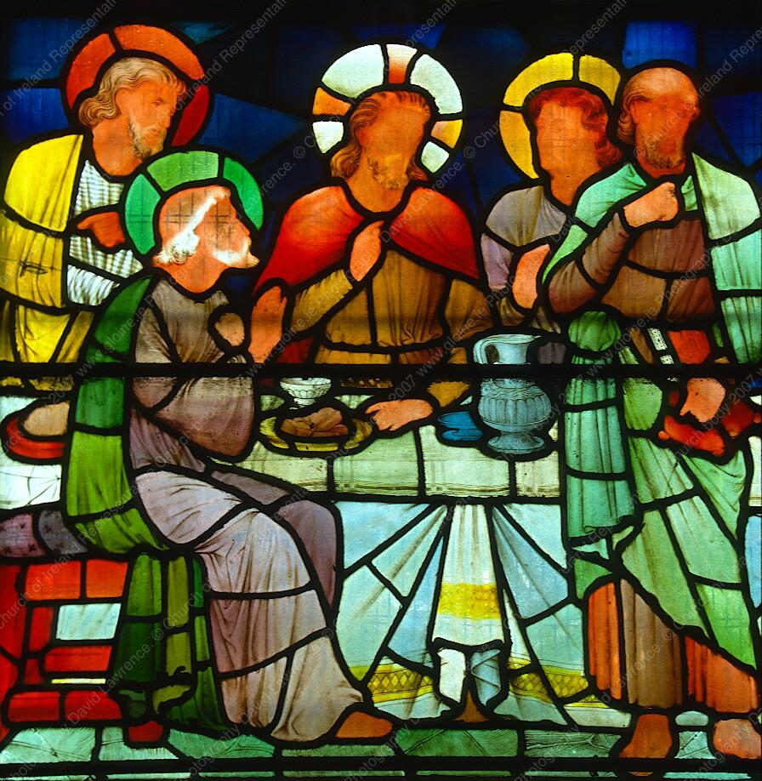

A retreat led by The Rt Revd Michael Burrows,
Bishop of Cashel, Ferns and Ossory
15th-19th April 2019

Church of Ireland theological institute
The Church of Ireland Commission on Ministry invites you to journey through Holy Week with a central but under-explored player in the Passion drama – Judas Iscariot. Through addresses, daily worship, silence and contemplation, Bishop Michael Burrows will explore the mystery and problem of Judas. As the week continues, he will challenge us to ask how meeting Judas in a new way may also be an encounter with some unfamiliar aspects of ourselves.

This is a residential retreat, based at The Church of Ireland Theological Institute. It will begin with lunch on the Monday of Holy Week and end on the morning of Good Friday. Retreatants will have the option of attending the Good Friday liturgy at a local parish church, or at one of the Cathedrals in Dublin.

Some places will be available for non-resident participants who wish to join in the whole retreat programme, but commute from home each morning.

The cost of the retreat, including accommodation and all meals, will be €250.
The cost for non-resident participants will be €120.

For further information please contact Dr Bridget Nichols:
Email bridgetnichols@theologicalinstitute.ie
Telephone (00353) (1) 4997279

BOOKING FORM

NAME ………………………………………………………….

ADDRESS ………………………………………………………….

EMAIL ………………………………………………………….

TELEPHONE ………………………………………………………….

MOBILE ………………………………………………………….

SPECIAL DIETARY REQUIREMENTS ……………………………………….

MOBILITY NEEDS ………………………………………………………….

I enclose a cheque for €250 (resident) OR €120 (non-resident), payable to The Church of Ireland Theological Institute

(or contact Lynda Levis for EFT details : lyndalevis@theologicalinstitute.ie)

Please return to
Lynda Levis,
The Church of Ireland Theological Institute,
Braemor Park
Churchtown
Dublin D14 KX24
Tel. (1) 492 3506

