ARTICLE PRINTED IN BELFAST TELEGRAPH –Good Friday 10th April, 2020
As we prepare to mark this holiday weekend in lockdown, Stephanie Bell asks some of our best known faces how their plans for catching up with family and attending church have changed
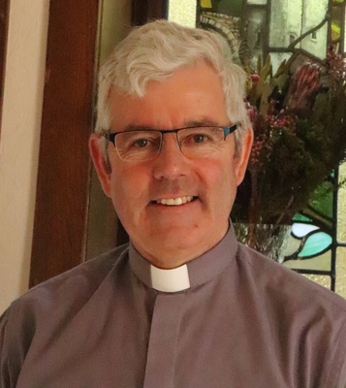

The Dean of Belfast, the Very Rev Stephen Forde, has been conducting Easter services on a live stream over the internet from his home throughout the week.
For him and his fellow clergymen, it is certainly proving to be a very different Holy Week but one which they are striving to make as special as possible for their congregations with online technology.
Rev Forde is currently on lockdown at home with his wife Fiona, a paediatric nurse, and his daughter Amy, a dietician with the Belfast Trust, her husband David Knox, a school teacher, and their daughter Eloise who is soon to turn two.
Rev Forde has another daughter, Rachel, who works in the health service in Dublin as an audiologist, and a son, Michael, a primary school teacher in Lancaster. All the family were due home to celebrate Easter together.
As plans changed dramatically with coronavirus, Rev Forde says he has been getting to grips with technology to keep services going during this very special week for St Anne's Cathedral.
"It has been very busy with services each day live-streamed from different rooms in my home.
"We will still have our Good Friday service, our Holy Saturday service and our Easter Day service on Sunday which will all be streamed on our website.
"I have just finished recording the service for Easter Day and grappling with technology to do it at home.
"We have a number of people doing readings and everyone recorded their part from home, and we have a member of our wider congregation in Portsmouth who is putting it all together for us.
"It is an entirely different experience trying to get on top of the different aspects of the internet and technology which have made it possible for us to have our services.
"Throughout Holy Week, each day we have had live services and it has worked three days out of four as the technology didn't connect on day four but we will be putting that online for people to watch.
"A large part of our congregation in the Cathedral would be older people who aren't necessarily confident around technology and the internet, so this week I have sent them an Easter letter and a copy of the order of service."
Throughout the week, as worship has continued through the internet, Rev Forde and his congregation have had special prayers for people working on the frontline to combat Covid-19.
He explains: "We are very much holding in our prayers all the people in the intensive care wards, patients and doctors and medics as well as frontline carers, shopkeepers and people working to keep our distribution network going."
At home, he and his family will be sitting down to Easter Sunday dinner - with some members missing.
However, once again the internet will help get everyone together.
"This year we had planned all to be together but will be tuning into a video message to have a virtual Easter egg which Eloise will happily hold to the camera for the others to take," he says.

